**COMPUTER NETWORKS**

**NAME: M.ISTAFA MALIK**

**ROLL: P190033**

**SECTION: BSCS-5A**

Task: Perform communication of four devices using switch

Solution:

Step 1Topology:

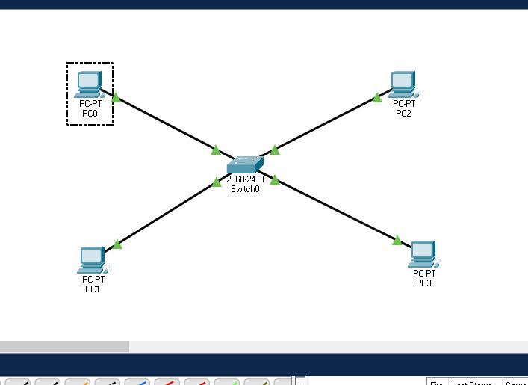

Step 2:

Assign IP’s to all end devices (PC’s) by clicking on the PC and then clicking the IP configuration option in the Desktop Box, like shown in the picture below.

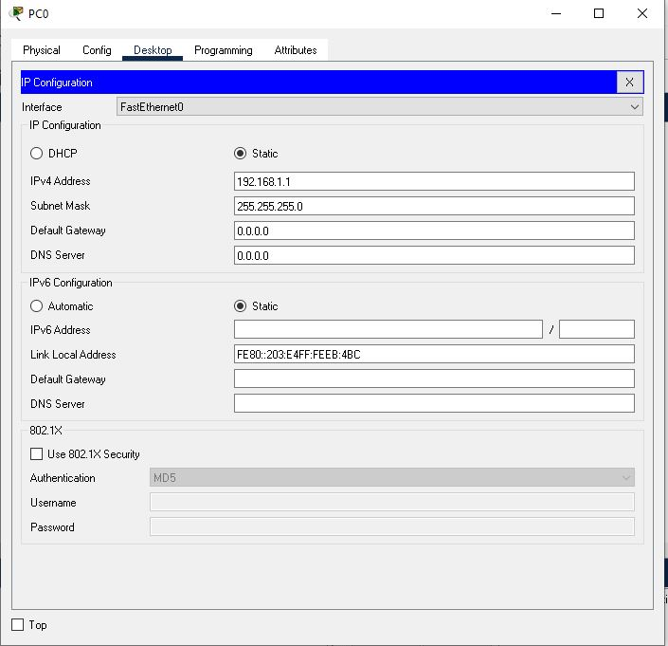

Step 3: Run it in real time to check if it’s working or not.

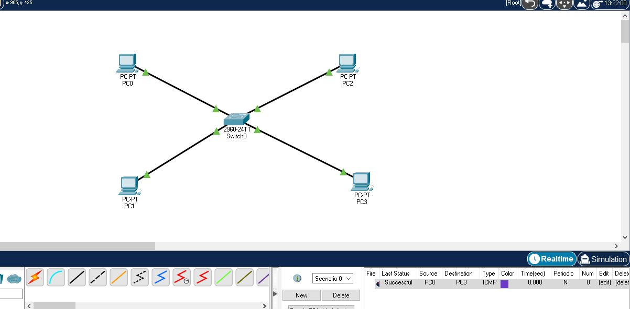

Step 4: Now run in simulation mode to understand it properly.

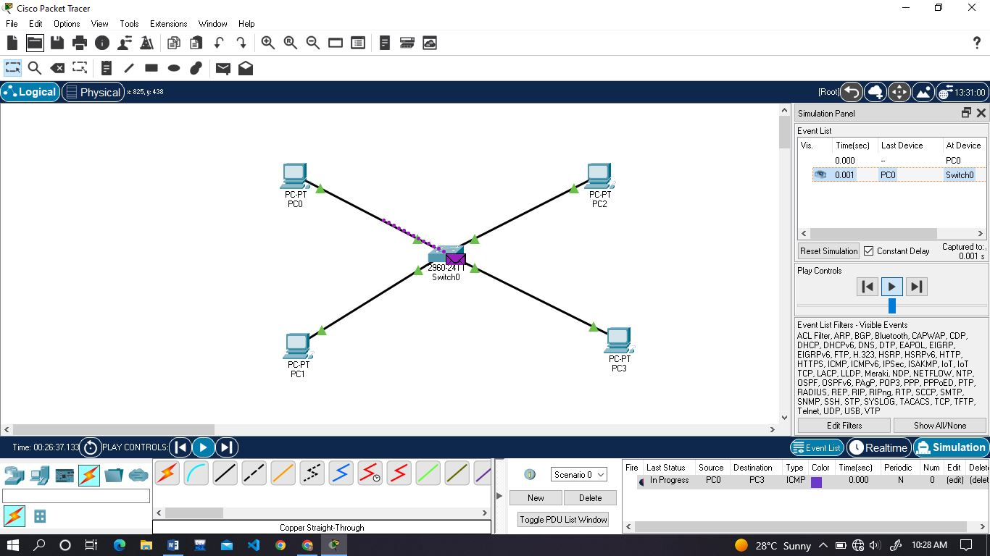

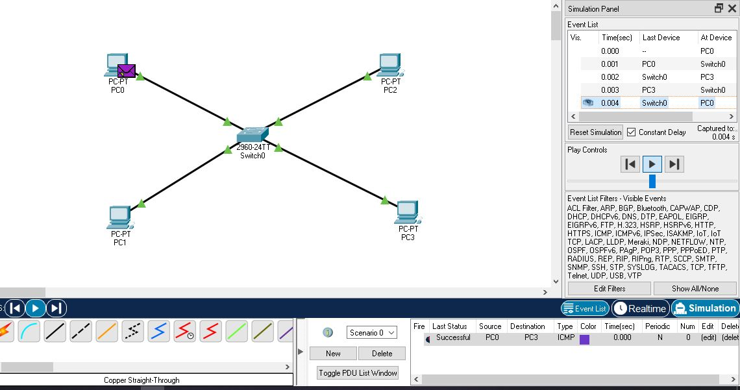

Task: Perform communication through multiple switches.

Solution:

Step 1: Topology

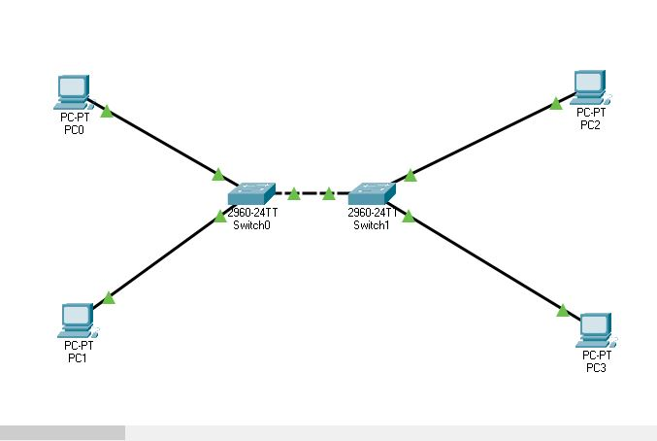

Step 2:

Assign IP’s to all end devices (PC’s) by clicking on the PC and then clicking the IP configuration option in the Desktop Box, like shown in the picture below.

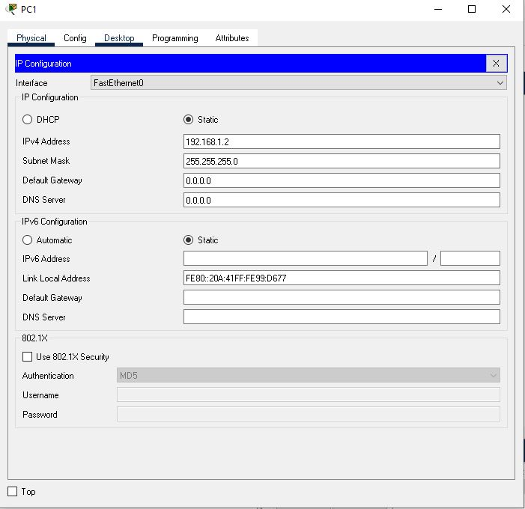

Step 3: Run it in real time to check if it’s working or not.

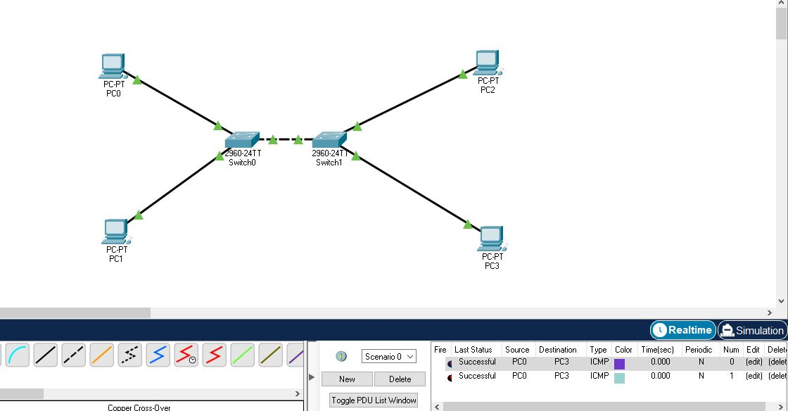

Step 4: Run it in simulation mode to understand it.

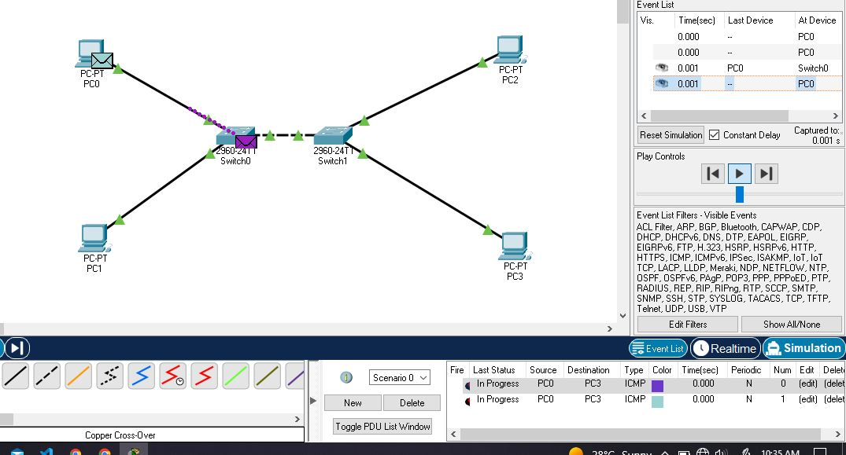

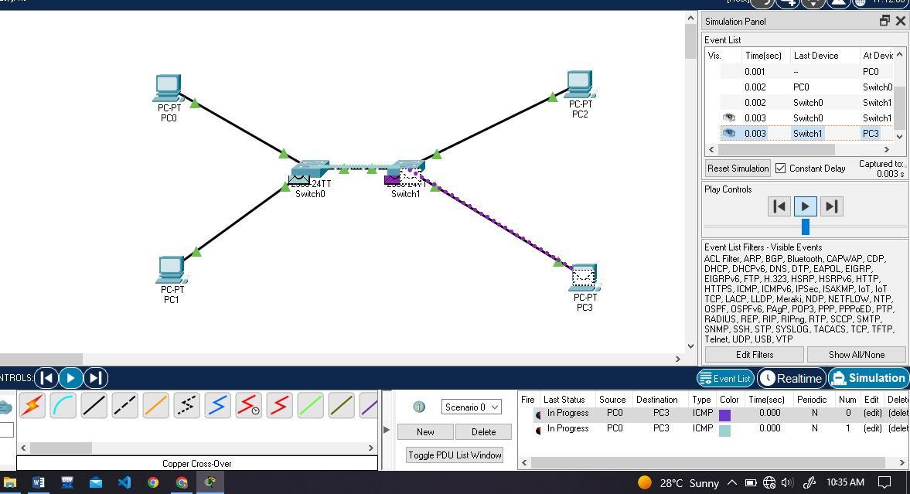

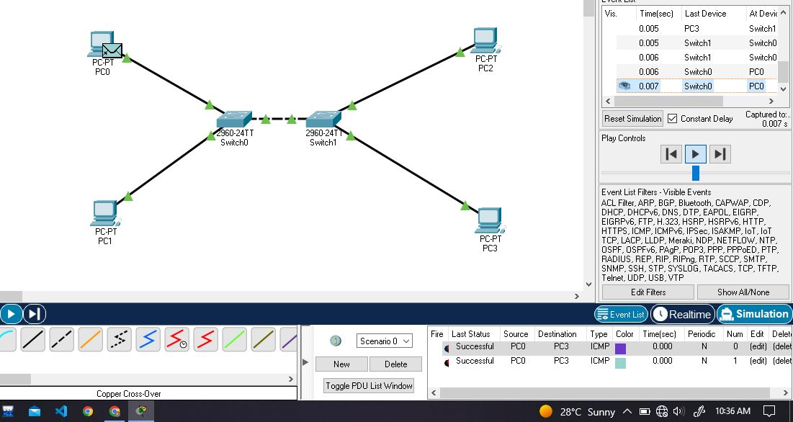

Task:

Solution:

Step 1: Topology

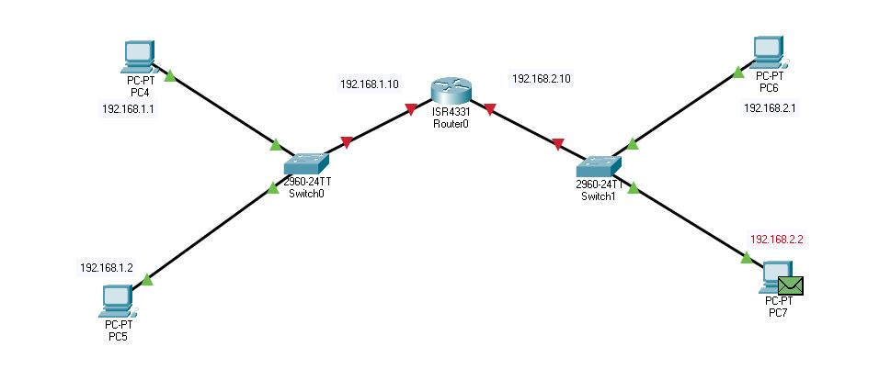

Step 2: Assign given IP’s to all PC’s and also assign default gateway to the PC with its associated Routers gateway.

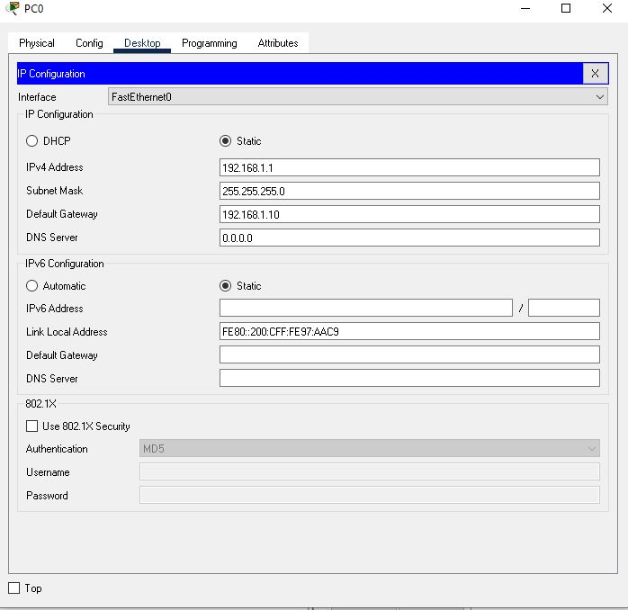

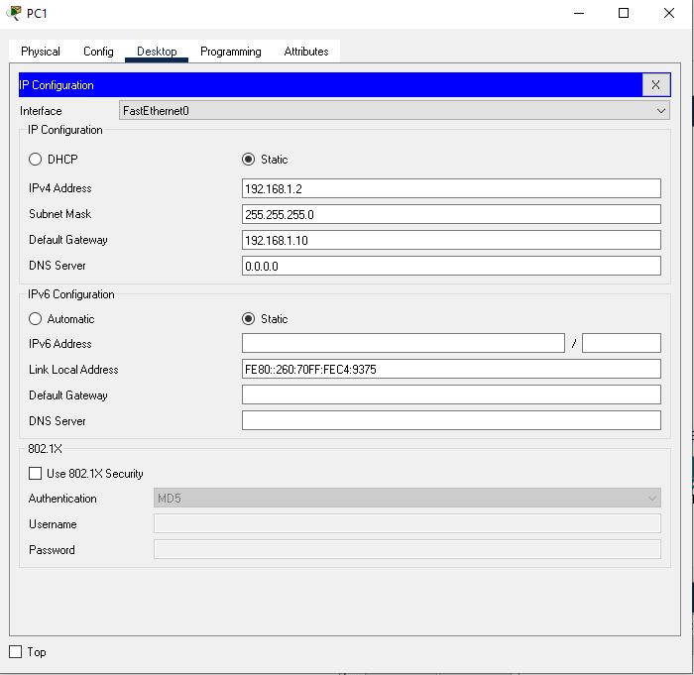

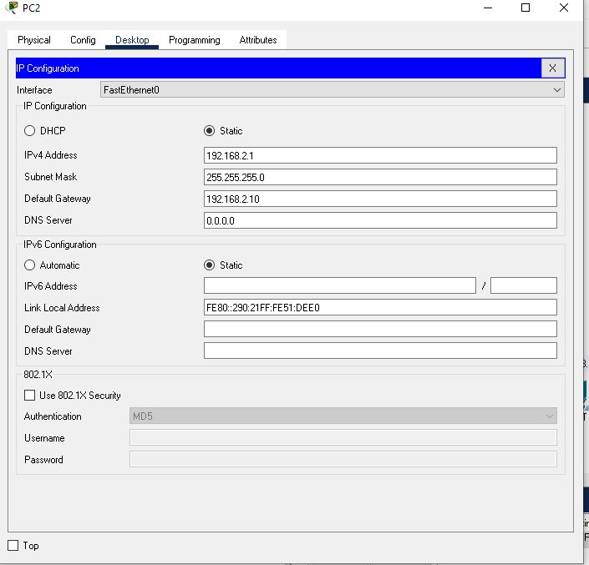

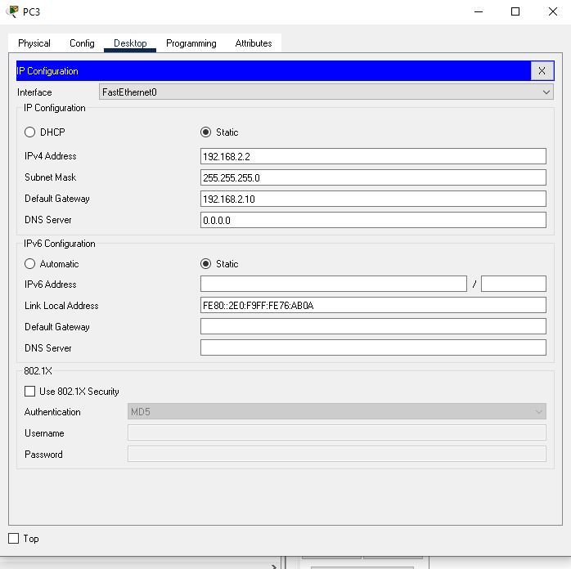

Step 3: Simulate in real time to check if it is working.

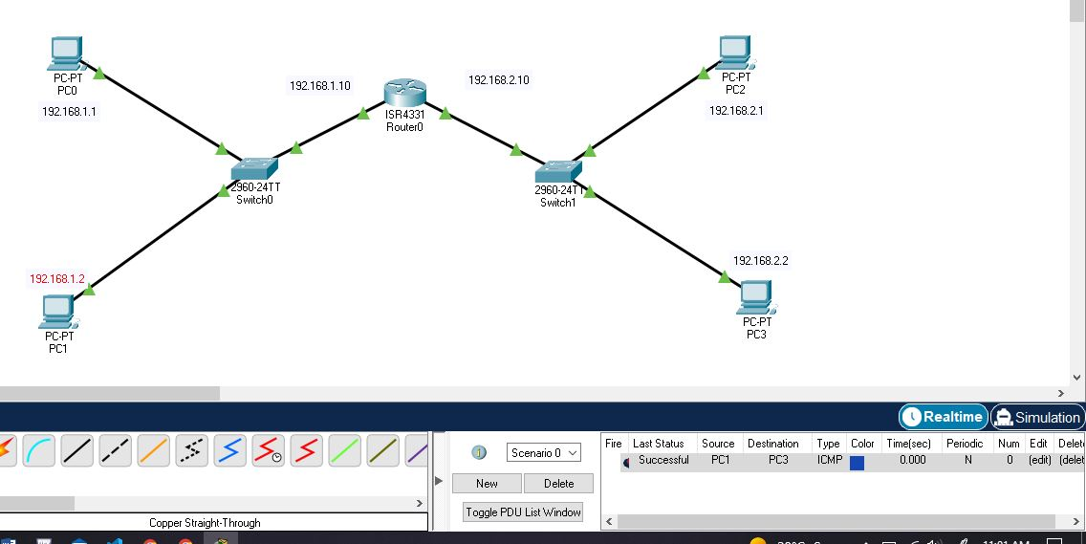

Step 4: Simulation mode to understand its working.

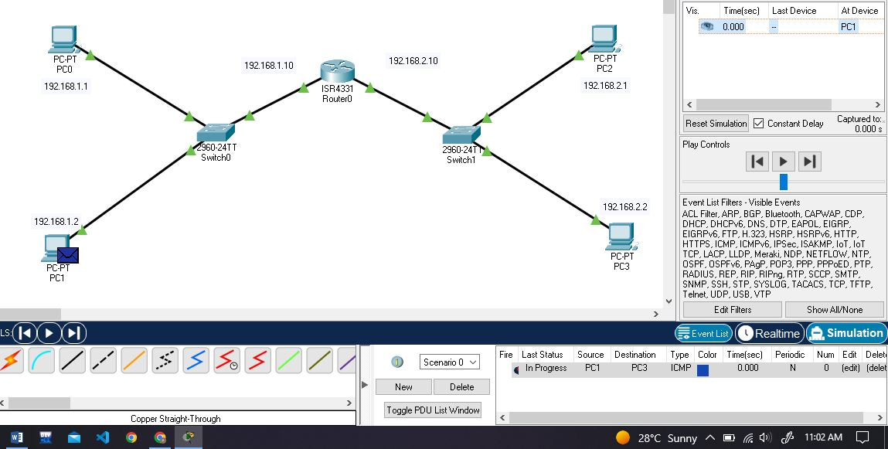

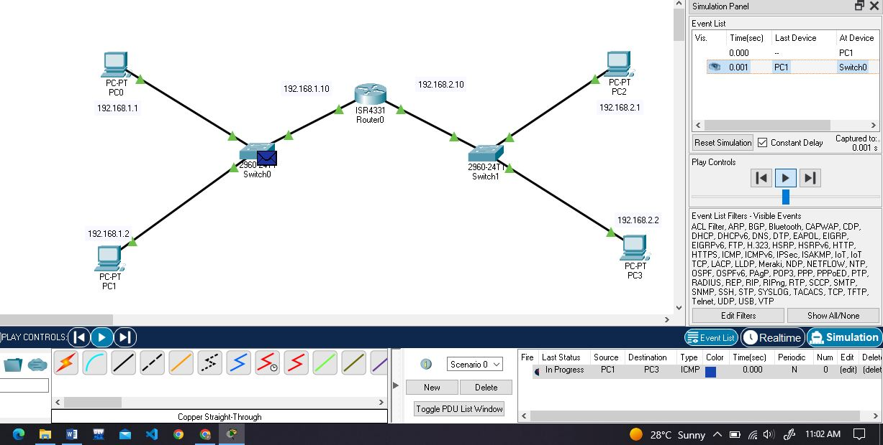

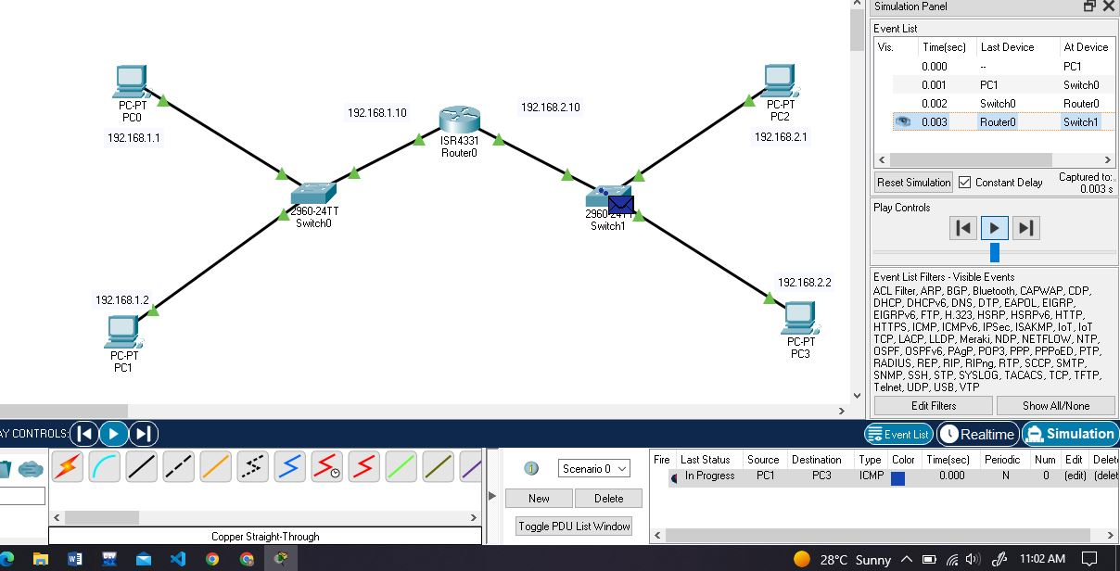

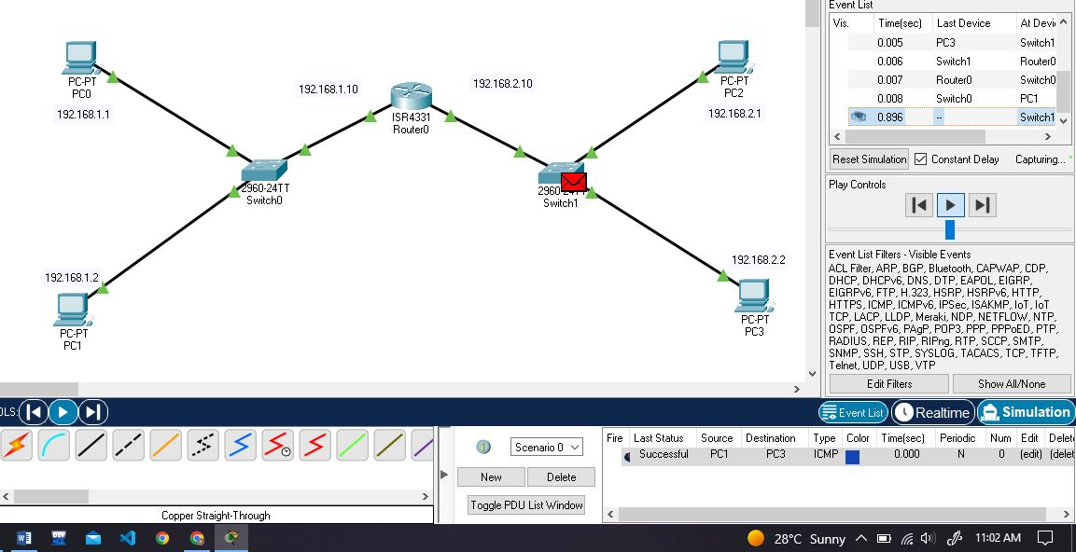

Task:

Solution:

Step 1: Topology

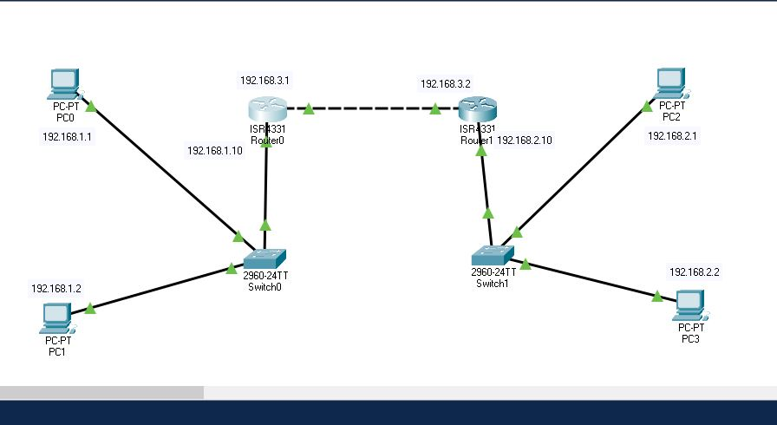

Step 2: Assign IP’s to all PC’s along with default gate way.  
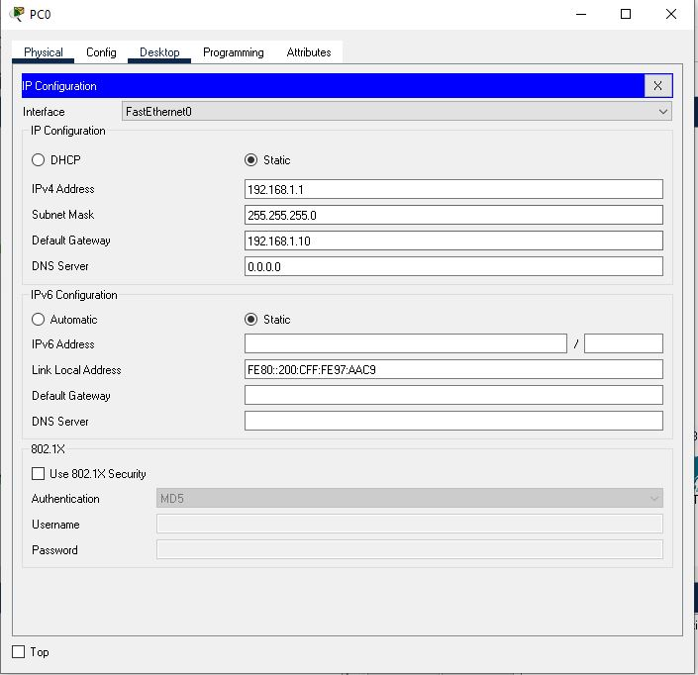

Step 3: Now configure router0 with the given data, by clicking configuration and then onto static in ROUTING option.

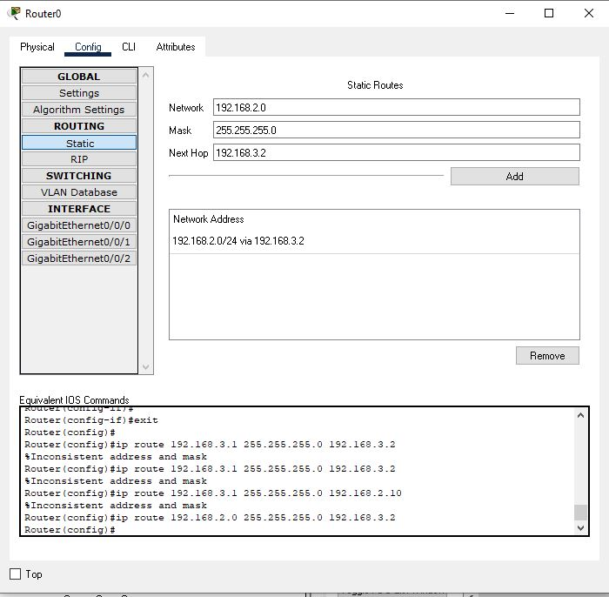

Do the same for router1.

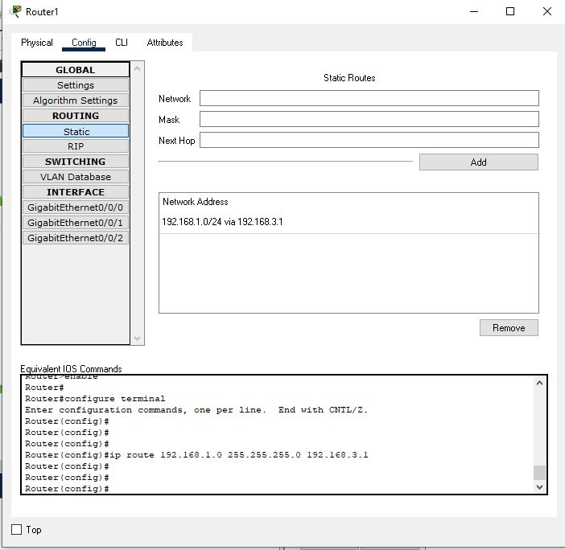

Step 4: Now send a packet in real time to see if it works or not.

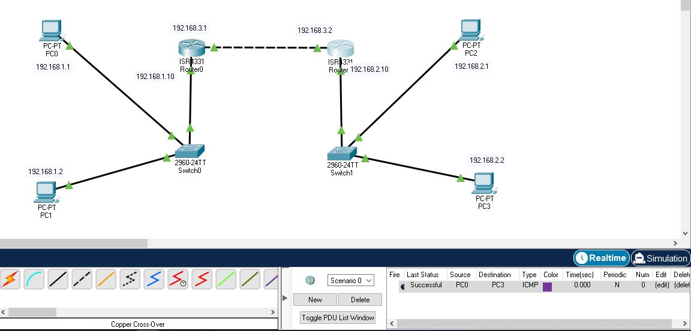

Step 5: Now use simulation mode to understand it.

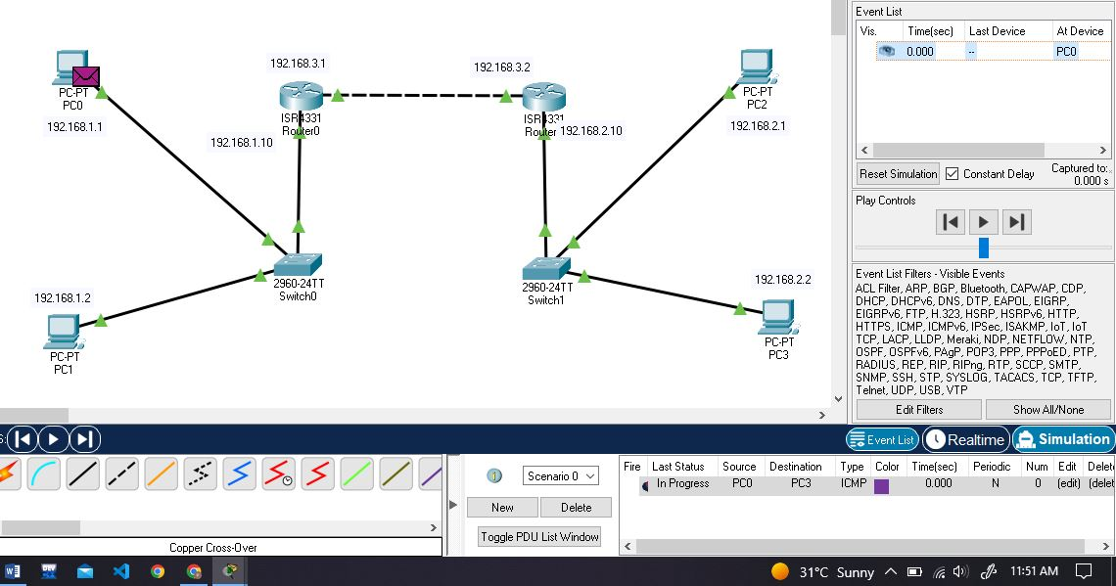

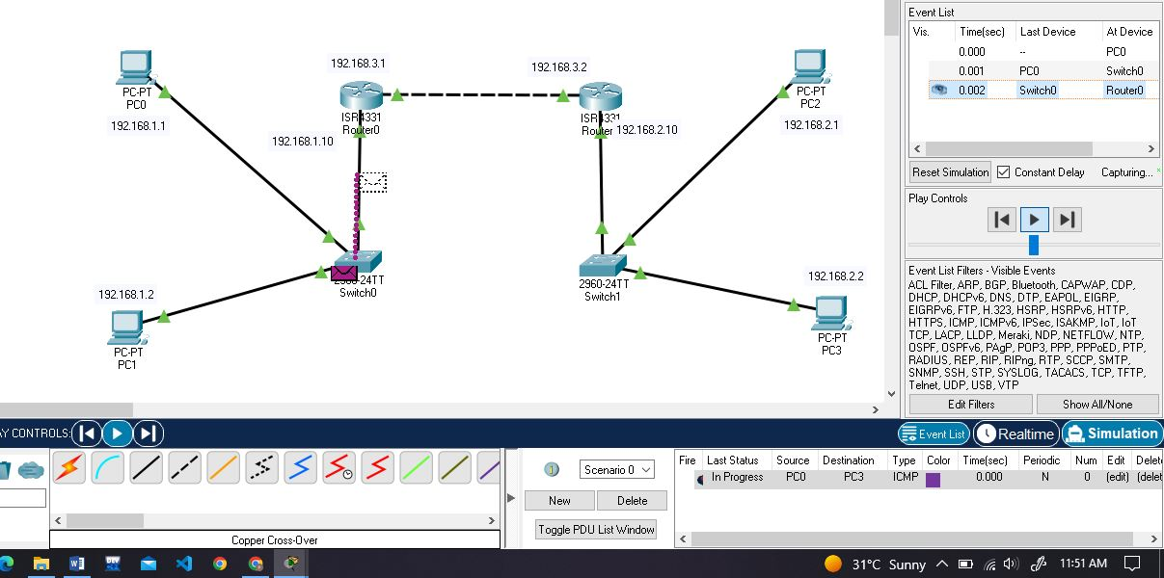

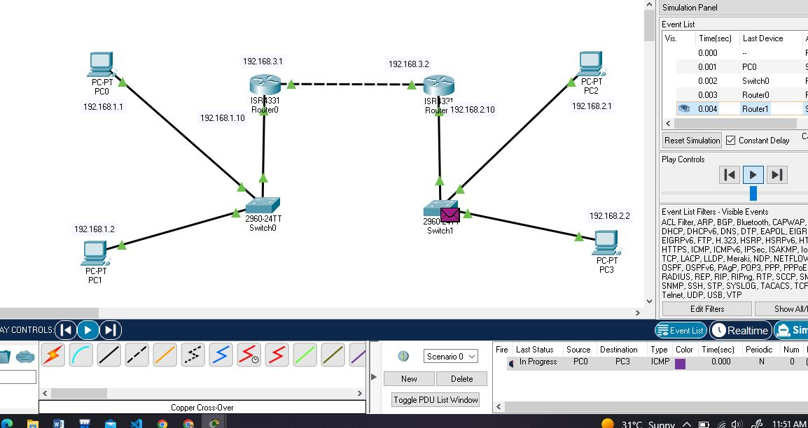

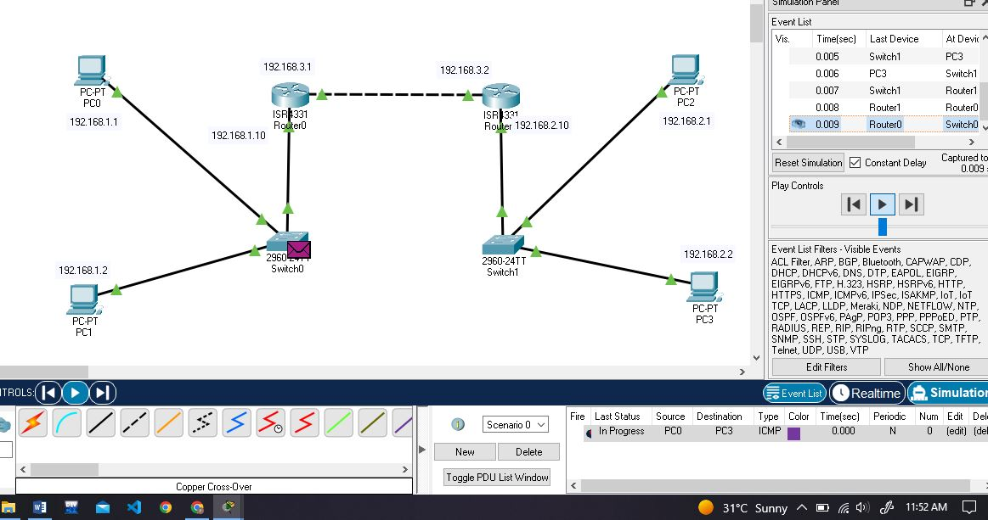

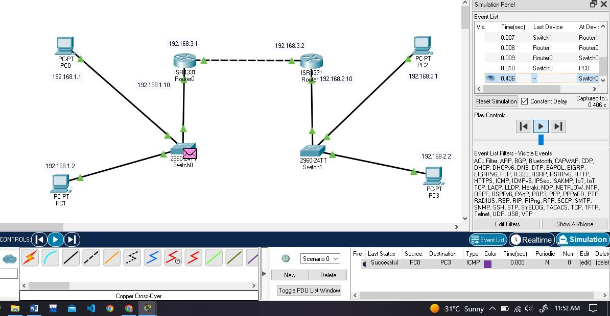

Task:

Solution:

Step1: Topology

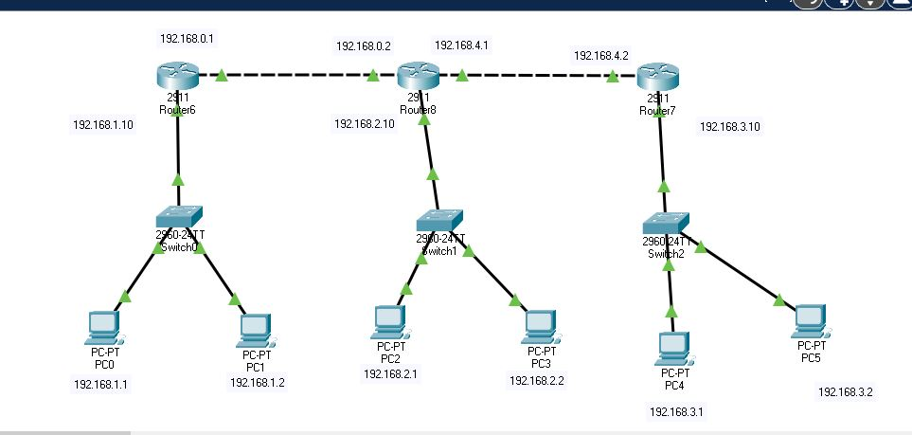

Step 2: Assign IP’s to all the PC’s and also default gateway.

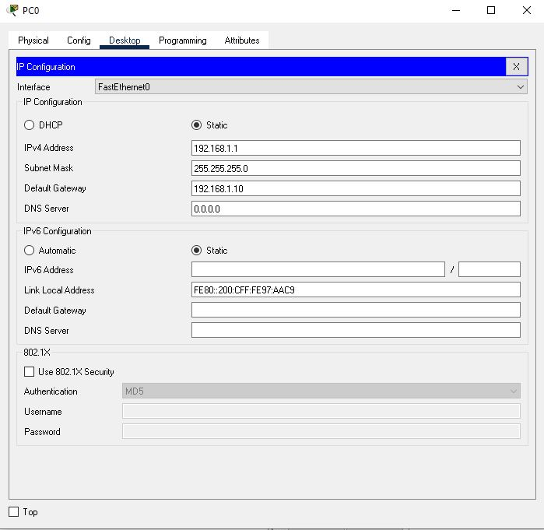

Step 3: Assign IP’s and configure router0.

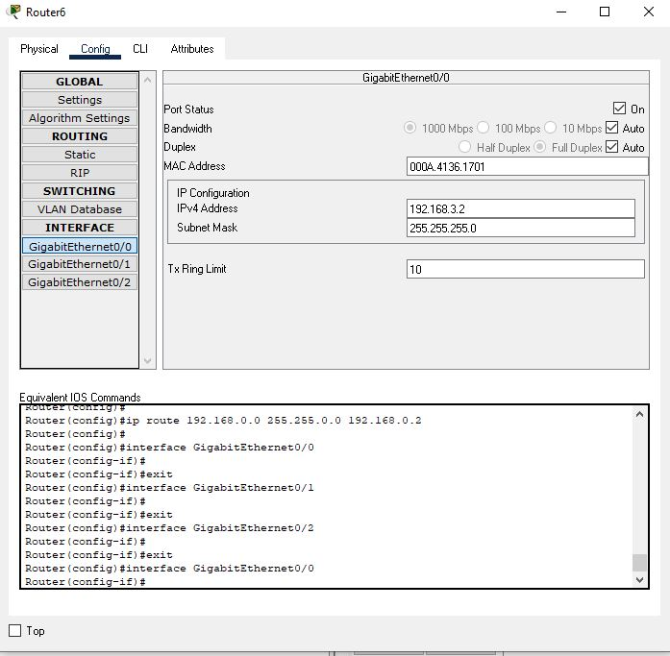

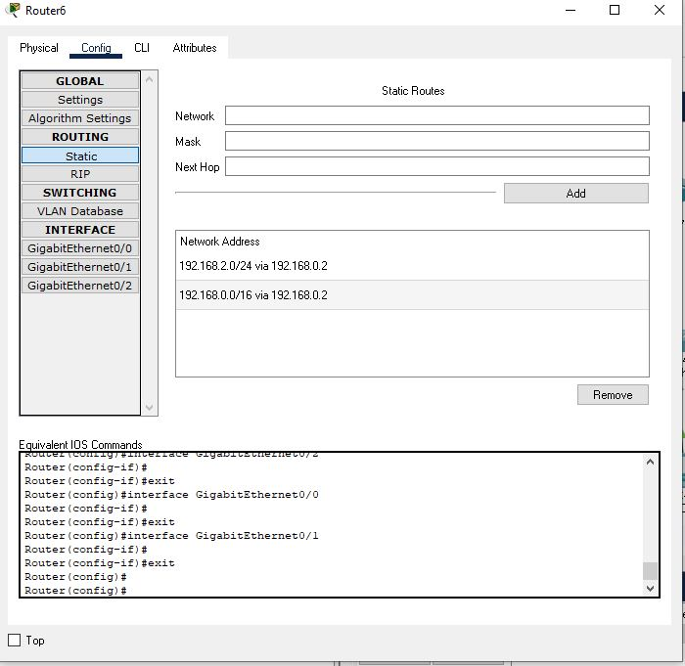

Do the same for router1

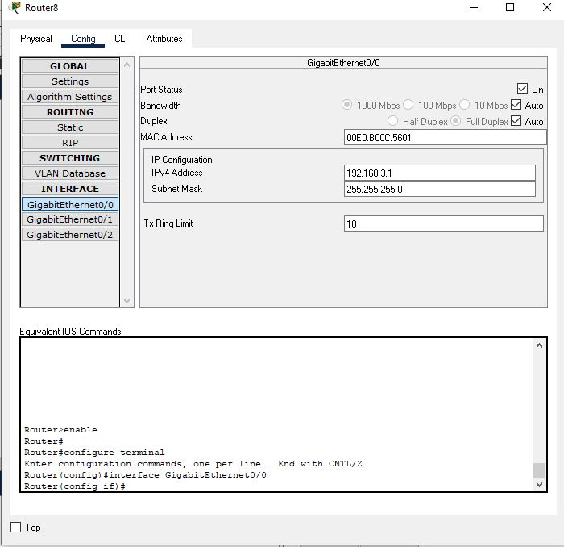

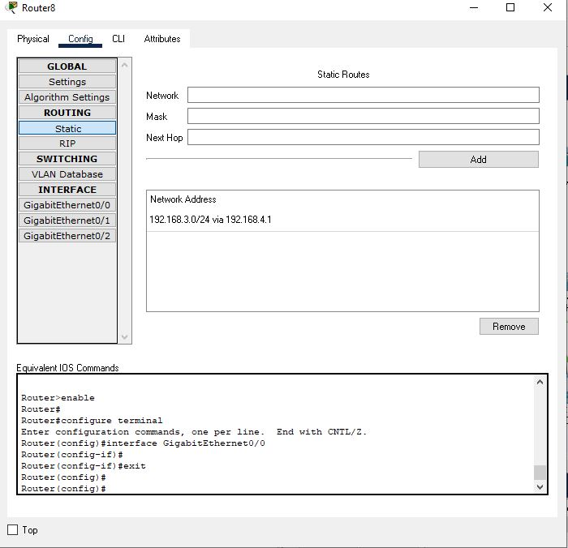

Do the same for router2

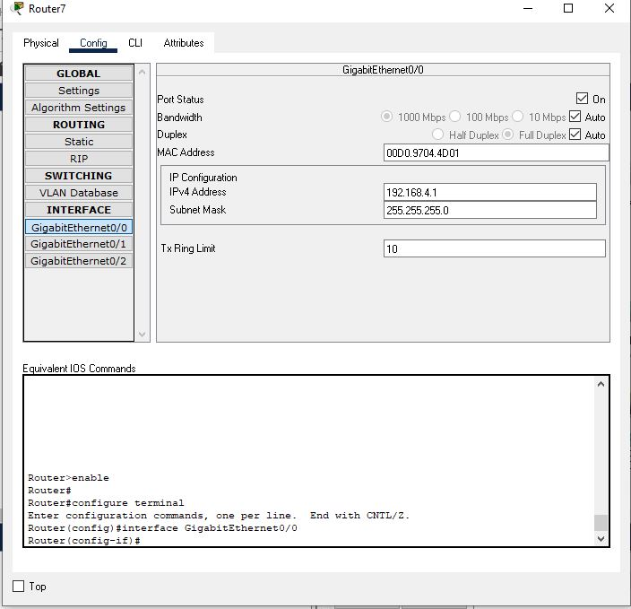

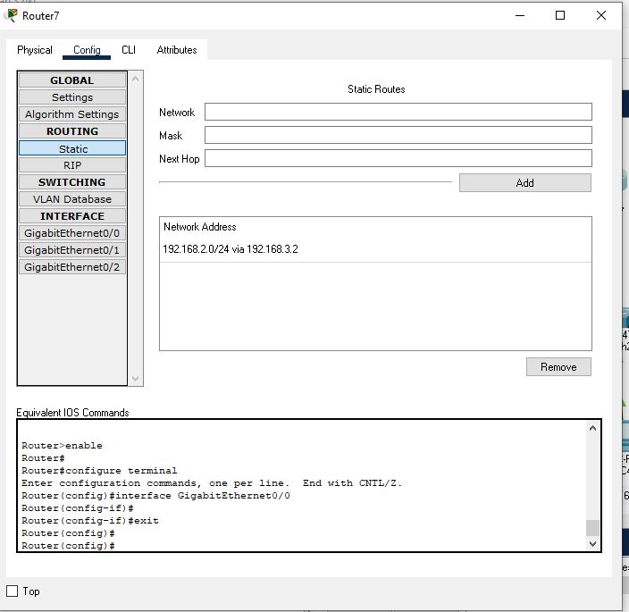

Step 4: Check in real time to see if it works or not.

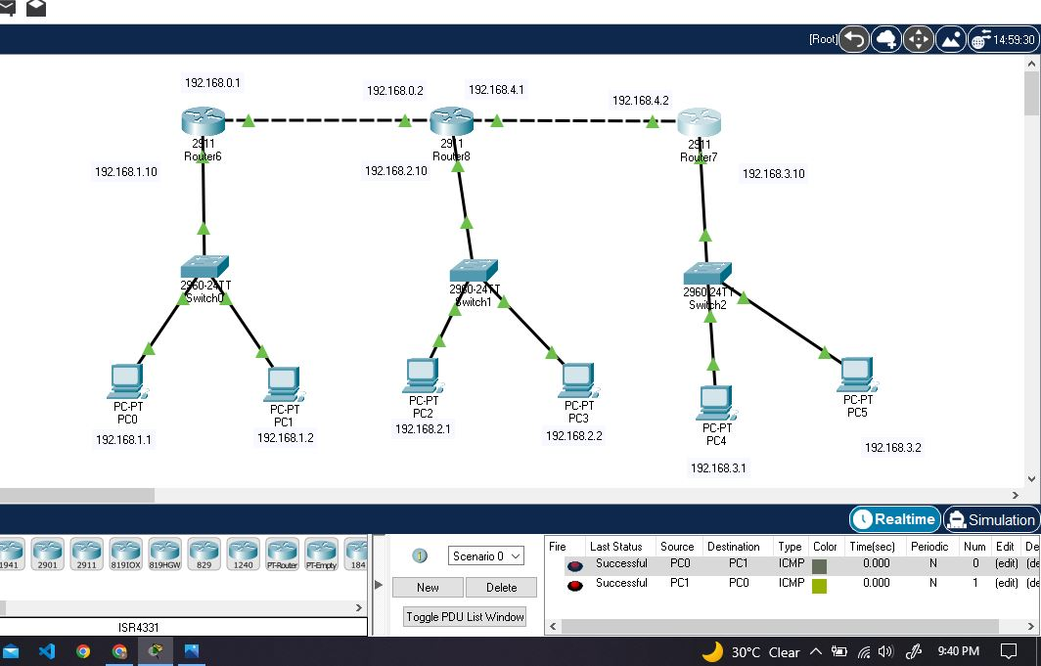

Step 5: Use simulation mode to understand better.

